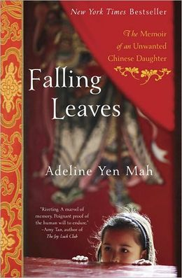
Mah, Adeline Yen. (1999) Falling Leaves. Crown Publishing Group
The themes presented in this book provide a look into Chinese culture of the 1940s/1950s through the 1990s (when the author moves to the United States, etc.) Questions that get students thinking about this culture could include:
- How is her family like yours? Unlike yours? (E.g., family problems are not shown to the outside world; boys are more worthy than girls; respect – or disrespect – for elders; parental treatment (or mistreatment) of children; treatment of one’s own children vs. step-children; following of dreams vs. conformity to family expectations).

- The author’s father is a very astute businessman. How does he navigate the Revolution? How do others in the family “navigate” it – or what happens when they are caught up in the movement?

- Food is a subject the author discusses repeatedly. The symbolism of food within her culture. How does food fit into her culture compared to your culture? (If students think that there is no “food culture”, ask them about Turkey, colored eggs, the seven seafoods (if Italian), etc.)

- Traditions often show themselves at changing points: birth, death, marriage, etc. How do the traditions shown by the author compare those practiced by her father? How do the author’s practices change? What do these traditions tell you about traditional Chinese culture?

- At the end, the author is still trying to please her father. What events during her life might make her not want to help her father? Why does she? What about her step-mother?

